**Customer’s Perspective**

The market for Rubik’s cubes includes gamers, parents of younger children, teachers, and other people looking for a casual single-person puzzle. Consumers looking to purchase a Rubik’s cube would likely be concerned chiefly with cost and quality. From a customer standpoint, a well-designed Rubik’s cube would need to take into consideration the cost of the materials necessary to create it, as well as the long-term durability of the product -- even after years of continuous use. Additional factors that potential customers may be concerned with include the outer appearance of the Rubik’s cube, e.g. the colors of the tiles on the facets and the color of the material used to manufacture the cube, as well as how easy it is to clean and maintain the cube’s exterior faces and interior components. To this end, a well-designed Rubik’s cube would need to be easily disassembled, for easy cleaning of the cube’s interior, and be relatively resistant to external damage -- water, soil, and the like. Though it should be able to be easily disassembled by an adult, the disassembly should not be simple or easy enough for a child, to prevent them from choking or swallowing on a piece. The cube would need to fulfill these requirements while making sure that the cost and long-term durability were not affected, though it also follows that a material chosen for resilience to regular wear-and-tear would logically also be durable in the long term.

**Engineer’s Perspective**

When designing a standard Rubik’s cube, it is firstly important to ensure that it conforms with a standard weight of 3.7 ounces and standard length of 2.25 inches on each side, similar to other cubes sold on the market. These dimensions also ensure the cube is easily held in one hand and is light enough as to be usable for long lengths of time without the user’s arms tiring. The material selected should be both lightweight and durable -- such as ABS plastic, a material known in the toy-making industry for its durability and relatively cheap cost. For ease of manufacturing, the pieces should be of standard size, so that errors in manufacturing can be easily corrected, and for cost reduction purposes, the least amount of material should be used -- e.g. the individual pieces of the cube should be hollow where possible, both to reduce the amount of material used and to reduce the weight of the product. In order to reduce signs of wear on the cube’s surface, it would also be ideal to use colored tiles to color the cube’s faces rather than stickers, which would likely peel off after extended use. The cube should also be designed so that when the sides are rotated, they do not rub against the interior of the cube, causing wear or making it hard to turn the cube’s faces. It would also be desirable for the Rubik’s cube to be simply assembled, so that it can be easily and efficiently mass produced. In addition, the edges of the cube should be rounded to prevent injury when solving the cube.

**Engineering Specifications list:**

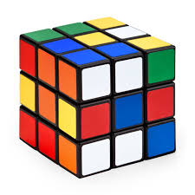 High quality molds to manufacture the product

 Rounded corners and edges to avoid injury

 Difficult for a small child to take apart by hand to avoid choking hazard

 Overall Length/Width/Height: 2.25” x 2.25” x 2.25”

 Length/Width of each color tile: 0.75” x 0.75”

 Weight: 3.5 ounces

 Material: Colored ABS Plastic, for strength and cost

 High quality interior mechanisms for smooth turning of faces

**Device Photos**

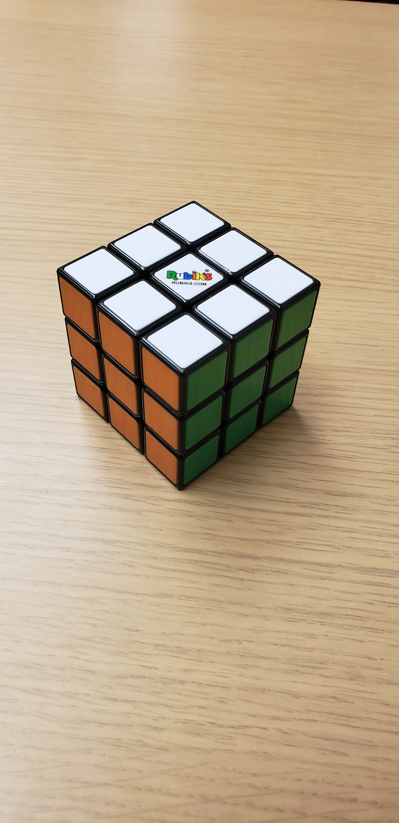

Isometric View

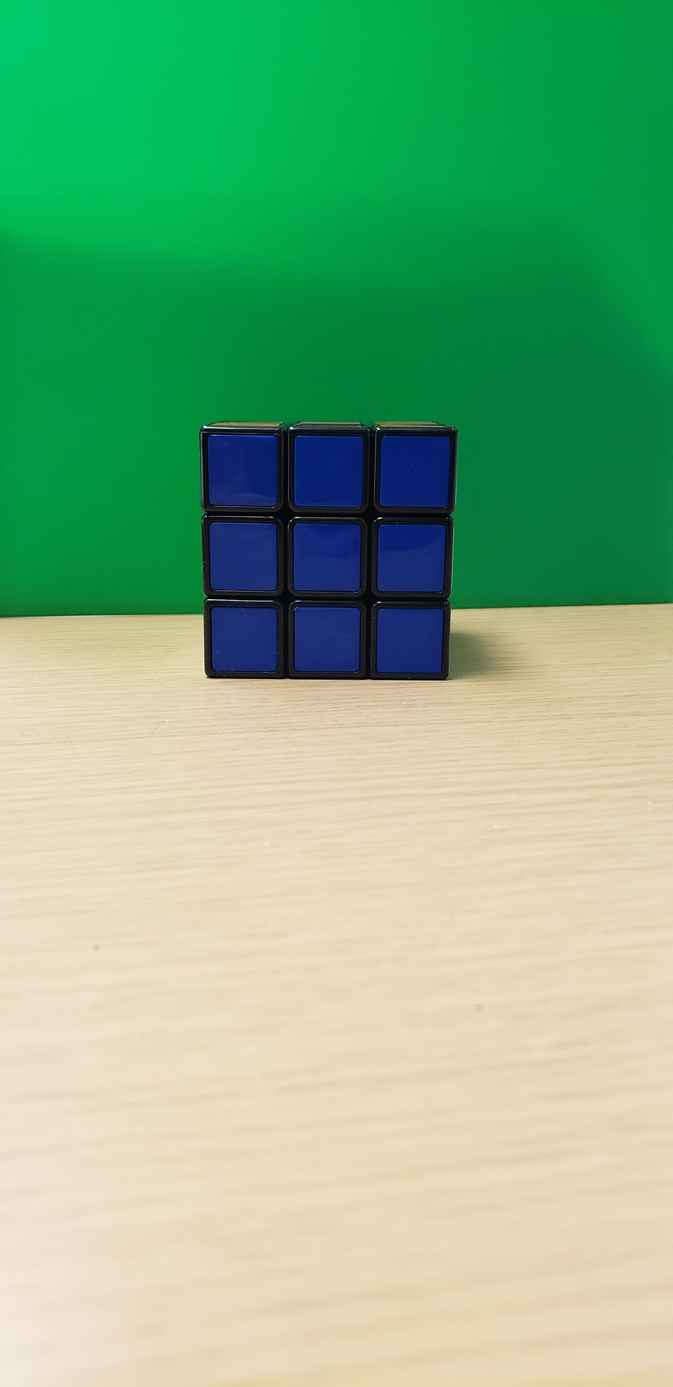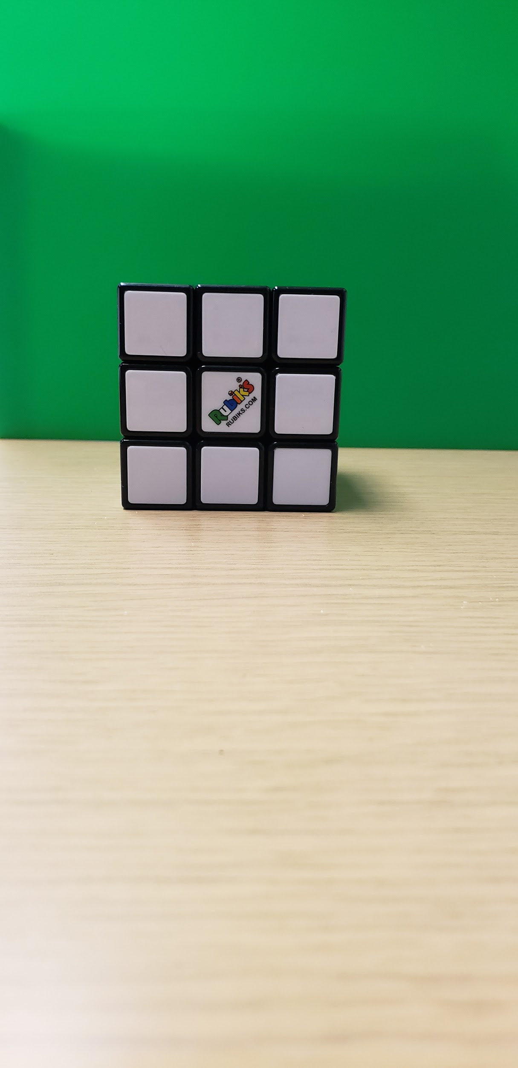

Front View

Side View